**ABASYN UNIVERSITY**

**ISLAMABAD CAMPUS**



|  |  |
| --- | --- |
| Student Name: | **Abdul Basit** |
| REG. Number: | **5027** |
| Department | **BSSE** |
| Subject: | **Modern Programming languages** |
| Course Code: |  |
| Instructor: | **Sir Zain Ul Islam Adil** |
| **Assignment** | **01** |

**Table of Content**

**1 Introduction……………………………………………………………………………………**

**2 Project Name………………………………………………………………………………….**

**3 Language…………………………………………………………………………………………**

**4 Code……………………………………………………………………………………………….**

**4 Output…………………………………………………………………………………………….**

# 

**Introduction**

Basic Calculator using Java language which performing basics mathematics operations (+, -, *, /)

**Project Name**

Calculator

**Language**

Java

**Code**

package calculator;

import java.awt.EventQueue;

import javax.swing.JFrame;

import java.awt.Color;

import javax.swing.JButton;

import java.awt.Font;

import java.awt.event.ActionListener;

import java.awt.event.ActionEvent;

import javax.swing.JLabel;

import javax.swing.SwingConstants;

import javax.swing.border.LineBorder;

import javax.swing.UIManager;

public class Calculator {

private JFrame frame;

private JLabel Screen;

private JLabel Ans;

private double f_number;

private String opr;

/**

* Launch the application.

*/

public static void main(String[] args) {

EventQueue.invokeLater(new Runnable() {

public void run() {

try {

Calculator window = new Calculator();

window.frame.setVisible(true);

} catch (Exception e) {

e.printStackTrace();

}

}

});

}

/**

* Create the application.

*/

public Calculator() {

initialize();

}

/**

* Initialize the contents of the frame.

*/

private void initialize() {

frame = new JFrame();

frame.getContentPane().setFont(new Font("Tahoma", Font.BOLD, 25));

frame.getContentPane().setForeground(Color.LIGHT_GRAY);

frame.getContentPane().setBackground(Color.LIGHT_GRAY);

frame.setBounds(100, 100, 407, 469);

frame.setDefaultCloseOperation(JFrame.EXIT_ON_CLOSE);

frame.getContentPane().setLayout(null);

JButton btnNewButton = new JButton("0");

btnNewButton.addActionListener(new ActionListener() {

public void actionPerformed(ActionEvent e) {

Screen.setText (Screen.getText()+"0");

}

});

btnNewButton.setFont(new Font("Tw Cen MT", Font.BOLD, 20));

btnNewButton.setForeground(Color.BLACK);

btnNewButton.setBounds(0, 386, 89, 33);

frame.getContentPane().add(btnNewButton);

JButton btnNewButton_1 = new JButton(".");

btnNewButton_1.addActionListener(new ActionListener() {

public void actionPerformed(ActionEvent e) {

Screen.setText (Screen.getText()+".");

}

});

btnNewButton_1.setForeground(Color.BLACK);

btnNewButton_1.setFont(new Font("Tw Cen MT", Font.BOLD, 20));

btnNewButton_1.setBounds(99, 386, 89, 33);

frame.getContentPane().add(btnNewButton_1);

JButton btnNewButton_2 = new JButton("=");

btnNewButton_2.addActionListener(new ActionListener() {

public void actionPerformed(ActionEvent e) {

double s_number;

s_number=Double.parseDouble(Screen.getText());

Screen.setText (Screen.getText()+"=");

if(opr.equals("+")) {

Ans.setText(Double.toString(f_number+s_number));

}

else if(opr.equals("-")) {

Ans.setText(Double.toString(f_number-s_number));

}

else if(opr.equals("*")) {

Ans.setText(Double.toString(f_number*s_number));

}

else {

Ans.setText(Double.toString(f_number/s_number));

}

}

});

btnNewButton_2.setForeground(Color.BLACK);

btnNewButton_2.setFont(new Font("Tw Cen MT", Font.BOLD, 20));

btnNewButton_2.setBounds(198, 386, 89, 33);

frame.getContentPane().add(btnNewButton_2);

JButton btnNewButton_3 = new JButton("+");

btnNewButton_3.addActionListener(new ActionListener() {

public void actionPerformed(ActionEvent e) {

opr="+";

f_number=Double.parseDouble(Screen.getText());

Screen.setText("");

Screen.setText (Screen.getText()+"+");

}

});

btnNewButton_3.setForeground(Color.BLACK);

btnNewButton_3.setFont(new Font("Tw Cen MT", Font.BOLD, 20));

btnNewButton_3.setBounds(297, 386, 89, 33);

frame.getContentPane().add(btnNewButton_3);

JButton btnNewButton_4 = new JButton("1");

btnNewButton_4.addActionListener(new ActionListener() {

public void actionPerformed(ActionEvent e) {

Screen.setText (Screen.getText()+"1");

}

});

btnNewButton_4.setForeground(Color.BLACK);

btnNewButton_4.setFont(new Font("Tw Cen MT", Font.BOLD, 20));

btnNewButton_4.setBounds(0, 326, 89, 33);

frame.getContentPane().add(btnNewButton_4);

JButton btnNewButton_5 = new JButton("2");

btnNewButton_5.addActionListener(new ActionListener() {

public void actionPerformed(ActionEvent e) {

Screen.setText (Screen.getText()+"2");

}

});

btnNewButton_5.setForeground(Color.BLACK);

btnNewButton_5.setFont(new Font("Tw Cen MT", Font.BOLD, 20));

btnNewButton_5.setBounds(99, 326, 89, 33);

frame.getContentPane().add(btnNewButton_5);

JButton btnNewButton_6 = new JButton("3");

btnNewButton_6.addActionListener(new ActionListener() {

public void actionPerformed(ActionEvent e) {

Screen.setText (Screen.getText()+"3");

}

});

btnNewButton_6.setForeground(Color.BLACK);

btnNewButton_6.setFont(new Font("Tw Cen MT", Font.BOLD, 20));

btnNewButton_6.setBounds(198, 326, 89, 33);

frame.getContentPane().add(btnNewButton_6);

JButton btnNewButton_7 = new JButton("-");

btnNewButton_7.addActionListener(new ActionListener() {

public void actionPerformed(ActionEvent e) {

opr="-";

f_number=Double.parseDouble(Screen.getText());

Screen.setText("");

//Screen.setText (Screen.getText()+"-");

}

});

btnNewButton_7.setForeground(Color.BLACK);

btnNewButton_7.setFont(new Font("Tw Cen MT", Font.BOLD, 20));

btnNewButton_7.setBounds(297, 326, 89, 33);

frame.getContentPane().add(btnNewButton_7);

JButton btnNewButton_8 = new JButton("4");

btnNewButton_8.addActionListener(new ActionListener() {

public void actionPerformed(ActionEvent e) {

Screen.setText (Screen.getText()+"4");

}

});

btnNewButton_8.setForeground(Color.BLACK);

btnNewButton_8.setFont(new Font("Tw Cen MT", Font.BOLD, 20));

btnNewButton_8.setBounds(0, 274, 89, 33);

frame.getContentPane().add(btnNewButton_8);

JButton btnNewButton_9 = new JButton("5");

btnNewButton_9.addActionListener(new ActionListener() {

public void actionPerformed(ActionEvent e) {

Screen.setText (Screen.getText()+"5");

}

});

btnNewButton_9.setForeground(Color.BLACK);

btnNewButton_9.setFont(new Font("Tw Cen MT", Font.BOLD, 20));

btnNewButton_9.setBounds(99, 274, 89, 33);

frame.getContentPane().add(btnNewButton_9);

JButton btnNewButton_10 = new JButton("6");

btnNewButton_10.addActionListener(new ActionListener() {

public void actionPerformed(ActionEvent e) {

Screen.setText (Screen.getText()+"6");

}

});

btnNewButton_10.setForeground(Color.BLACK);

btnNewButton_10.setFont(new Font("Tw Cen MT", Font.BOLD, 20));

btnNewButton_10.setBounds(198, 274, 89, 33);

frame.getContentPane().add(btnNewButton_10);

JButton btnNewButton_11 = new JButton("*");

btnNewButton_11.addActionListener(new ActionListener() {

public void actionPerformed(ActionEvent e) {

opr="*";

f_number=Double.parseDouble(Screen.getText());

Screen.setText("");

//Screen.setText (Screen.getText()+"*");

}

});

btnNewButton_11.setForeground(Color.BLACK);

btnNewButton_11.setFont(new Font("Tw Cen MT", Font.BOLD, 20));

btnNewButton_11.setBounds(297, 274, 89, 33);

frame.getContentPane().add(btnNewButton_11);

JButton btnNewButton_12 = new JButton("7");

btnNewButton_12.addActionListener(new ActionListener() {

public void actionPerformed(ActionEvent e) {

Screen.setText (Screen.getText()+"7");

}

});

btnNewButton_12.setForeground(Color.BLACK);

btnNewButton_12.setFont(new Font("Tw Cen MT", Font.BOLD, 20));

btnNewButton_12.setBounds(0, 218, 89, 33);

frame.getContentPane().add(btnNewButton_12);

JButton btnNewButton_13 = new JButton("8");

btnNewButton_13.setBackground(UIManager.getColor("Button.background"));

btnNewButton_13.addActionListener(new ActionListener() {

public void actionPerformed(ActionEvent e) {

Screen.setText (Screen.getText()+"8");

}

});

btnNewButton_13.setForeground(Color.BLACK);

btnNewButton_13.setFont(new Font("Tw Cen MT", Font.BOLD, 20));

btnNewButton_13.setBounds(99, 218, 89, 33);

frame.getContentPane().add(btnNewButton_13);

JButton btnNewButton_14 = new JButton("9");

btnNewButton_14.setBackground(UIManager.getColor("Button.shadow"));

btnNewButton_14.addActionListener(new ActionListener() {

public void actionPerformed(ActionEvent e) {

Screen.setText (Screen.getText()+"9");

}

});

btnNewButton_14.setForeground(Color.BLACK);

btnNewButton_14.setFont(new Font("Tw Cen MT", Font.BOLD, 20));

btnNewButton_14.setBounds(198, 218, 89, 33);

frame.getContentPane().add(btnNewButton_14);

JButton btnNewButton_15 = new JButton("/");

btnNewButton_15.addActionListener(new ActionListener() {

public void actionPerformed(ActionEvent e) {

opr="/";

f_number=Double.parseDouble(Screen.getText());

Screen.setText("");

//Screen.setText (Screen.getText()+"/");

}

});

btnNewButton_15.setForeground(Color.BLACK);

btnNewButton_15.setFont(new Font("Tw Cen MT", Font.BOLD, 20));

btnNewButton_15.setBounds(297, 218, 89, 33);

frame.getContentPane().add(btnNewButton_15);

Screen = new JLabel("");

Screen.setBorder(new LineBorder(Color.WHITE, 3));

Screen.setFont(new Font("Tahoma", Font.BOLD, 20));

Screen.setForeground(Color.BLACK);

Screen.setBackground(Color.BLACK);

Screen.setBounds(0, 35, 391, 53);

frame.getContentPane().add(Screen);

Ans = new JLabel("");

Ans.setBorder(new LineBorder(Color.WHITE, 2));

Ans.setBackground(Color.LIGHT_GRAY);

Ans.setHorizontalAlignment(SwingConstants.RIGHT);

Ans.setFont(new Font("Tahoma", Font.BOLD, 20));

Ans.setForeground(Color.WHITE);

Ans.setBounds(0, 98, 391, 53);

frame.getContentPane().add(Ans);

JButton btnNewButton_16 = new JButton("Clear");

btnNewButton_16.setFont(new Font("Tahoma", Font.BOLD, 14));

btnNewButton_16.addActionListener(new ActionListener() {

public void actionPerformed(ActionEvent e) {

Screen.setText("");

}

});

btnNewButton_16.setBounds(133, 162, 89, 35);

frame.getContentPane().add(btnNewButton_16);

JLabel lblNewLabel = new JLabel("Mamoon Ejaz 4545");

lblNewLabel.setForeground(Color.BLACK);

lblNewLabel.setBackground(Color.WHITE);

lblNewLabel.setFont(new Font("Tahoma", Font.BOLD, 20));

lblNewLabel.setBounds(10, 0, 256, 24);

frame.getContentPane().add(lblNewLabel);

}

}

**Output**

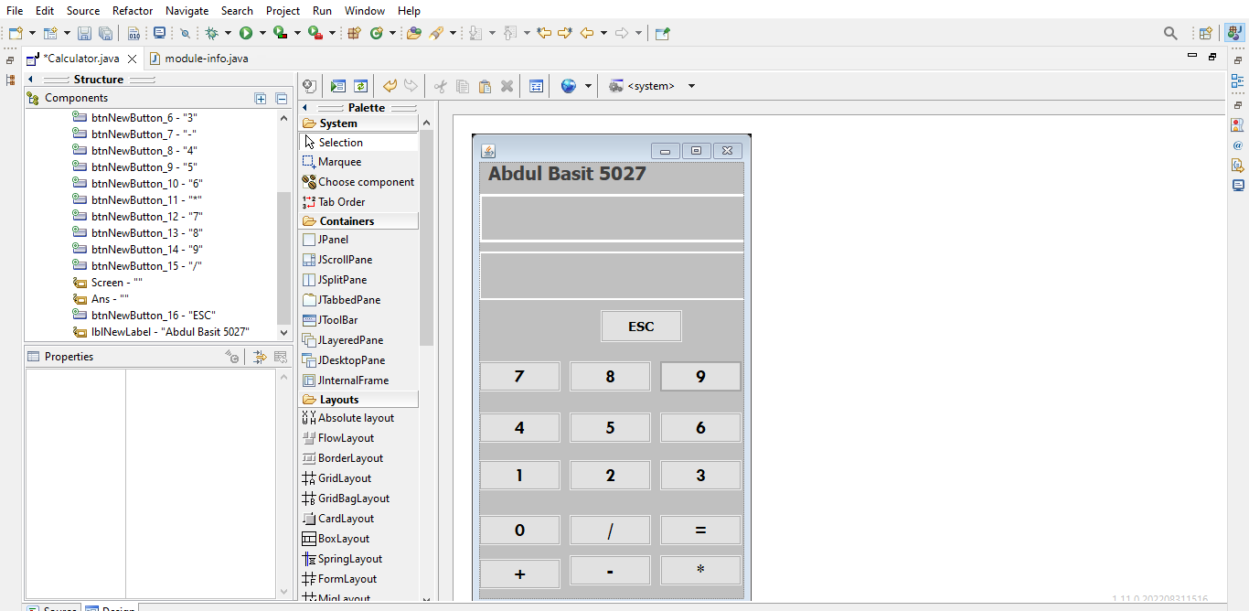

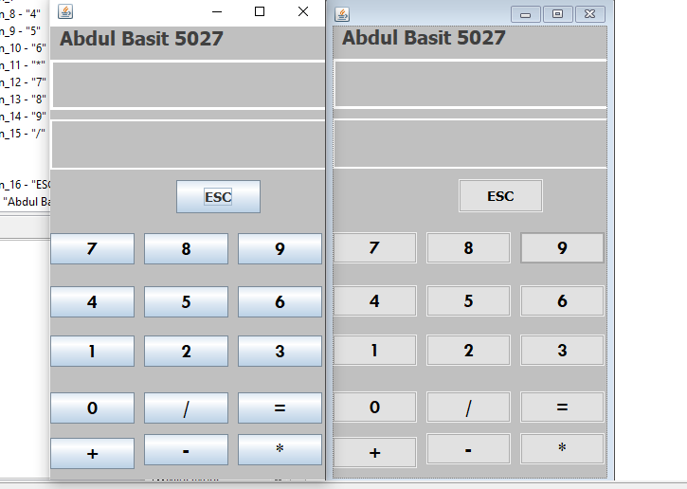

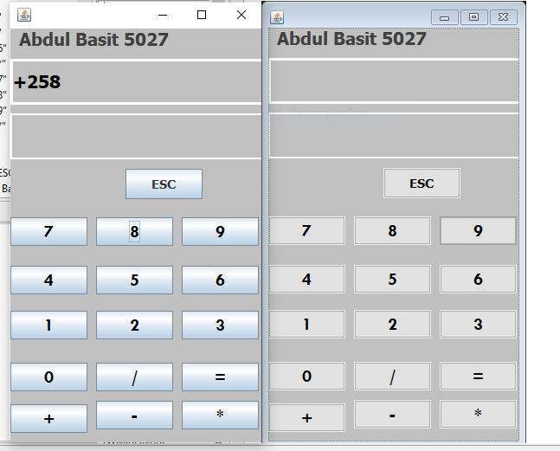

**Description : In my calculator we perform addition , subtraction , multiplication and division. Here we can add ,sub, multiple and divide two or more number.**

**Github link:**

**https://github.com/Abdulbasit451/Assignment.git**

END